DRAFT – Still Under Development

Sonar Propagation Modeling using Hybrid Gaussian Beams in Spherical/Time Coordinates

August 3, 2011

Sean M. Reilly
University of Rhode Island
Ocean Engineering Department

Abstract

This paper defines a new undersea acoustic transmission loss model that is optimized for real-time, sonar simulation/stimulation systems in littoral environments. The ray solutions to the eikonal equation are computed in latitude, longitude, and altitude coordinates to match wide-area environmental databases. Hybrid Gaussian beam techniques for transmission loss calculation are used to extend the applicability of ray theory to lower frequency regimes. Numerical integration of the wave equation is performed in the time dimension to support broadband signal modeling. This 3-D approach also supports out-of-plane reflection from the ocean bottom. This paper derives the eikonal solution from first principles to ensure a complete understanding of the coordinate system’s impact.

Introduction

This paper defines a new undersea acoustic transmission loss model that is optimized for real-time, sonar simulation/stimulation systems in littoral environments. The features of this model are:

- The ray solutions to the eikonal equation are computed in latitude, longitude, and altitude coordinates to match wide-area environmental databases. This avoids the need to translate sound speed and bottom parameters into a series of 2-D radials. Avoiding this step results in a significant computational savings, especially when the dynamics of the scenario preclude the reuse of environment parameters over multiple runs.

- Hybrid Gaussian Beam techniques for transmission loss calculation are used to extend the applicability of ray theory to lower frequency regimes. The Gaussian Ray Bundling (GRAB) model has successfully used these techniques to support frequencies as low as 150 Hz.

- Numerical integration of the eikonal equation is performed in the time dimension to support broadband signal modeling. Unlike the arc length scheme used in many other models, the time domain maintains the continuity of the wave front and allows the direct calculation of a broadband environment impulse response with each integration step.

- This 3-D approach also supports out-of-plane reflection from the ocean bottom. Models that use 2-D environments over a series of radials cannot support this littoral effect.

The use of the latitude, longitude, altitude coordinate system is similar to the approach used by the HARPO model. But instead of using an implicit integration the Hamiltonian to trace rays as a function of arc length, this effort uses an explicit integration of the eikonal to trace rays as a function of travel time. These changes are designed to create a significant improvement in computation speed, but they sacrifice HARPO’s ability to include advection effects in the propagation calculation. In theory, the predictor/corrector qualities of HARPO’s integrator should also make it a more accurate calculation. But, this accuracy improvement only provides a significant benefit when the environmental conditions are known to a high order of accuracy and not in real-time, sonar simulation/stimulation systems. This paper derives the eikonal solution from first principles to ensure a complete understanding the coordinate system’s impact.

Classic ray theory background

Classic ray theory decomposes acoustic waves into surfaces of constant travel time (τ) from the source (Figure 1). The rays are a vector field that is normal to these surfaces at each point in space. The route of these rays through the medium defines the direction of propagation. In the high frequency limit, spreading loss occurs as the energy of the wavefront is stretched over increasingly larger areas during propagation. Classic ray theory uses the change in distance between rays to model the spreading effects of wavefront propagation.
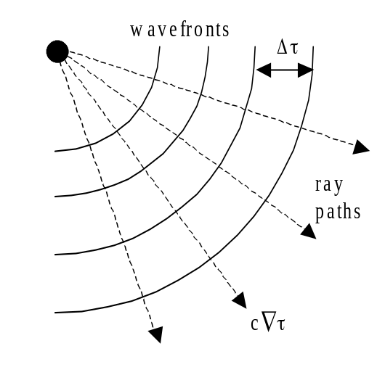
Figure 1 – Acoustic Ray Geometry

Ray theory separates the Helmholtz equation into a transport equation (eqn. (1)) that defines the strength of the field, and an eikonal equation (eqn. (2)) that defines the direction of propagation.

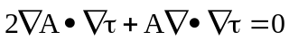 (1)
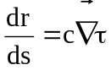 (2)
where:

= position coordinate along a ray path,
s = distance along the ray path,
c = speed of sound in water,
A = wavefront amplitude, and
τ = travel time along the ray path.

Equations 1 and 2 are an exact solution of the wave equation in the geometric limit, that is, when the sound speed gradient along the direction of motion changes slowly compared to the acoustic wavelength. This treatment starts to break down at lower frequencies as soon as diffraction starts to play a significant role in propagation.
The eikonal equation (eqn. (2)) can be solved² by recognizing 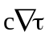as the propagation of energy along the ray paths. This realization transforms the eikonal equation into a second order ordinary differential equation in terms of, c, and s:
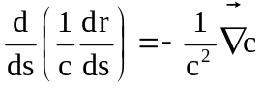 (3)
By introducing the temporary variable, the eikonal equation is reduced to a pair of simultaneous first order equations.

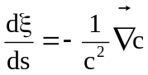 (4)
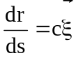 (5)
Numerical integration algorithms, solve this set of equations as a series of arc length steps given initial conditions. Equation (5) illustrates the temporary variable is actually the direction of propagation scaled by the speed of sound, or equivalently the wave number vector divided by the angular frequency.

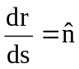 (6)
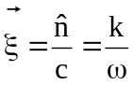 (7)
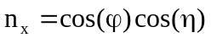 (8)
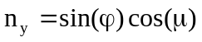 (9)
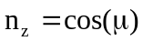 (10)
where:

= direction of propagation = (n_{x}, n_{y}, n_{z}),
= acoustic wave number vector,
ω = angular frequency,
ϕ = azimuthally steering angle, and
μ = depression/elevation steering angle.

This conceptual understanding of allows us to initialize the system of equations represented by eqns. (4) and (5) with the position and steering angle for each ray path at its source. Marching the simultaneous first order equations through steps in arc length generates ray paths throughout the water column. In classic ray theory, the spreading loss of the wavefront at any point is calculated by measuring the spreading between adjacent rays. Because adjacent rays have different travel times in this treatment, there is an implicit assumption that transmission loss is being calculated for a continuous ensonification at a single frequency.

New model for the path of propagation

Conversion into the time domain

The assumption that discreet rays can characterize the continuous wave field assumes some form of interpolation between propagation paths. Smooth fields allow the use of a larger interpolation grid without a loss of accuracy. The narrowband approximation in the arc length form (eqns. (4) and (5)) introduces roughness into the field that can only be mitigated by decreasing the step size. To avoid this problem, a change of variables (eqn. (11)) is used to transform the ray equations into a function of travel time.

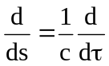 (11)
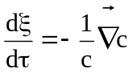 (12)
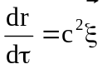 (13)
This form of the marching solution computes propagation as a series of steps in travel time and the phase coherence between rays is preserved at each step. This form of the ray equation represents an impulse response of the environment in the high frequency limit. Although the ray paths represented by eqns. (12) and (13) are independent of frequency, they can include frequency dependent effects of seawater absorption and interface reflection.

Ray propagation in spherical/time coordinates

Up to this point, the ray tracing formulas have been expressed in vector form and no underlying coordinate system has been assumed. This section derives a specific implementation of these algorithms in a spherical coordinate system based on latitude, longitude, and altitude (depths are treated as negative altitudes). The World Geodetic System 1984 (WGS-84) reference ellipse is used to represent zero altitude worldwide (aka. mean sea level). A spherical polar coordinate system is constructed within each area of operations, and its radius is set equal to the WGS-84 radius of curvature at the center of the operation (Figure 2).

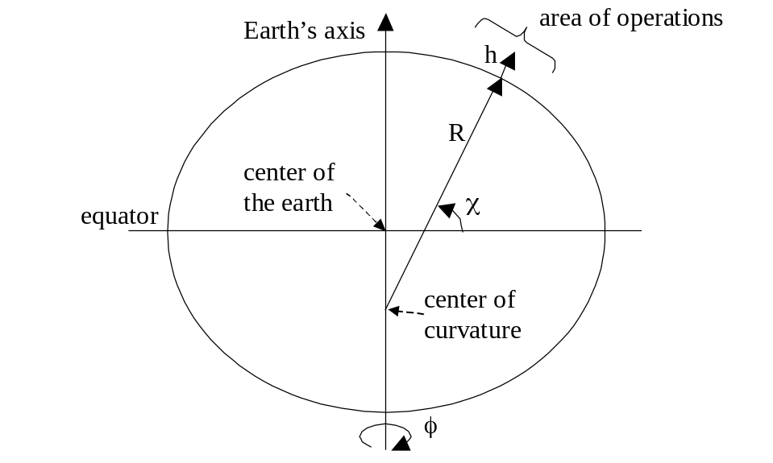
Figure 2 – Spatial Coordinates

The coordinate system is illustrated in Figure 2 where:

χ = latitude,
φ = longitude,
h = altitude above mean sea level,
R = radius of earth’s curvature for the area of operations.
r = distance from center of curvature = R + h, and
θ = co-latitude = 90° - χ,

The average radius of curvature in the area of operations is a combination of radii in the latitude and longitude directionsError: Reference source not found

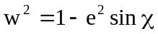 (14)
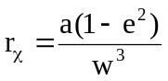 (15)
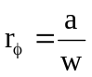 (16)
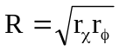 (17)
where

e = elliptic eccentricity from WGS-84,
r_{χ}, r_{φ} = radius of curvature in latitude and longitude directions, and
R = average radius of curvature in area of operations.

This coordinate system defines all quantities in terms the spherical polar properties (r, θ, φ). The transformation of eqns. (12) and (13) into this coordinate system uses the fact that the ray position only has radial components, while the ray direction has components in all three dimensions.

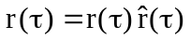 (18)
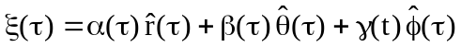 (19)
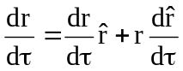 (20)
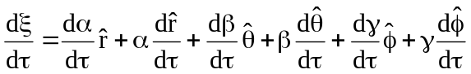 (21)
where

α(τ) = radial component of the normalized ray direction,
β(τ) = co-latitude component of the normalized ray direction, and
γ(τ) = longitude component of the normalized ray direction.

The calculation of the ray path uses the fact that the unit vectors, and change as a function of r, θ, and φ. The effect on the time derivative is derived by casting the unit vectors for the r, θ, and φ direction into their Cartesian coordinate equivalents before applying the time derivative.

(22)
(23)
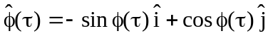 (24)
It is left as an exercise for the reader that the chain rule, when applied to eqns. (22), (23), and (24) yields the following time derivatives in spherical coordinates:
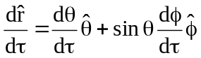 (25)
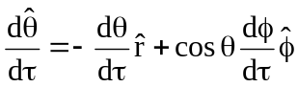 (26)
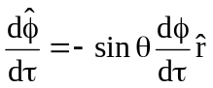 (27)
Applying eqns. (21) through (23) to eqns. (12) and (13) transforms the ray tracing equations in spherical polar form:

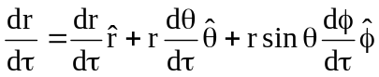 (28)
(29)
Matching terms for, and yields a system of six (6) first-order, scalar differential equations:

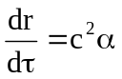 (30)
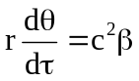 (31)
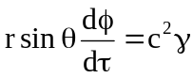 (32)
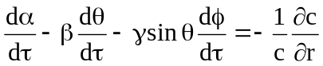 (33)
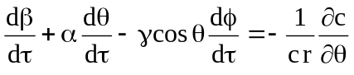 (34)
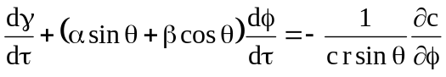 (35)
When eqns. (26) though (28) are plugged into eqns. (29) though (31), the system is reduced to a state where all of the ray derivatives appear only once.

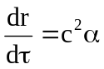 (36)
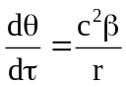 (37)
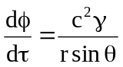 (38)
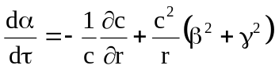 (39)
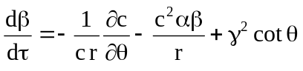 (40)
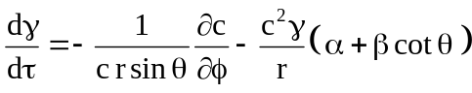 (41)
Equations (36) through (41) are equations of motion that represent the location and normalized direction for any acoustic ray based on its initial conditions. This form automatically follows great circle routes between locations. It automatically includes ray curvature corrections for over the horizon acoustic propagation. Environmental parameter derivatives are calculated directly in latitude, longitude, and altitude without reducing the problem to a series of 2-DxN radials or a flat earth Cartesian projection. Since most wide-area environmental databases present data in this form, this approach significantly reduces computer load by not requiring a pre-computation transformation.

Adams-Bashforth stepping algorithm

This model uses a third order Adams-Bashforth (AB3) algorithm3 to integrate eqn, (36) through (41) numerically. The AB3 technique approximates the each step in the solution for f(t) as:

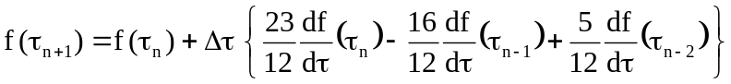 (42)
Each new point in the iteration is estimated using a linear combination of terms from the three (3) time steps that came before it. Because these past values can be cached, AB3 is much faster other methods with similar accuracy. Because AB3 is not self-starting, this model uses a third order Runge-Kutta (RK3) algorithm whenever the ray parameters must be initialized, or re-initialized.

When equations (36) through (41) are equations are processed using (42), the computationally expensive trigonometric calculations are reduced to a single sin(θ) and cot(θ) factor. The interpolation of the speed of sound and its gradient are also limited to a single instance per iteration. Derivative information from previous time-steps is carried forward and reused at each subsequent time step.

Although the calculation in spherical coordinates is more computationally expensive than an equivalent calculation in Cartesian coordinates, there is a significant overall saving by avoiding transformation of the environmental inputs. These savings will be most significant in highly dynamic 3-D simulation environments where the re-use of pre-computed environments is not practical.

Boundary reflections

Estimating the time of collision
h
d
2
d
s
r
I
1
Figure 3 – Estimating the point of collision

The first step in an interface collision is estimating the point in time when the incident ray strikes the bottom. The derivation of the equations for estimating the time of collision in spherical coordinates uses the symbols defined in Figure 3:

= surface normal at the point of collision,
= radial normal at the point of collision,
= incident ray path,
h = incident ray height above bottom,
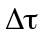 = normal time step, and
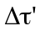 = time step needed to reach interface.

If the bottom slope is nearly constant across the length of the incident ray, then the ratio of the time steps is equivalent to the ratio of the distances normal to the surface.

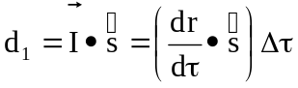 (43)
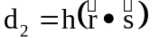 (44)
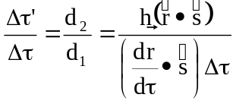 (45)
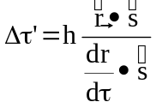 (46)
At the ocean surface, this simplifies to
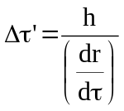 (47)
where the derivative in the denominator is the radial ray tracing component defined in equation (36).
A second order Taylor expansion of terms in equation (42) is used to improve the accuracy of the collision point and grazing angle calculations. This model estimates each component of the position, normalized direction, and sound speed at the point of collision using the following approximations:
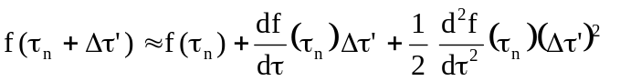 (48)
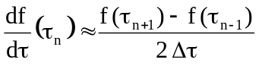 (49)
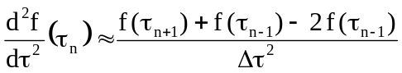 (50)

Reflection from a 3-D slope
s
A
A
R
I
Figure 4 – Reflection from a 3-D slope

The next step in an interface collision is estimating the direction of reflection from a 3-D slope. The derivation of the equations for estimating the direction of reflection in spherical coordinates uses the symbols defined in Figure 4:

= surface normal at the point of collision,
= incident ray path direction,
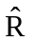 = reflected ray path direction, and
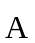 = component of incident perpendicular to surface normal.

Since the reflected ray has the same angle to the normal as the incident ray:

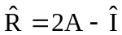 (51)
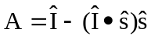 (52)
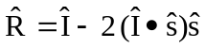 (53)
For ocean surface reflections, these relationships negate the sign of the radial component while leaving the θ and φ direction components unchanged.

Most bottom depth databases grid the relief of the earth’s surface into a series of latitude and longitude points. Equating the slope (σ_{θ,φ}) to the first derivative of the boundary allow us to compute the spherical components of the surface normal (s_{r,θ,φ}).

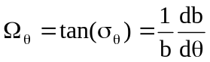 (54)
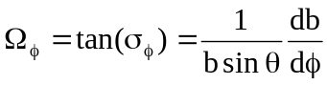 (55)
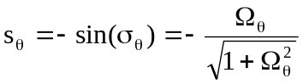 (56)
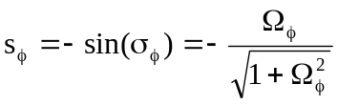 (57)
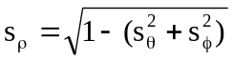 (58)
After reflection, the ray must be reinitialized in a way that maintains the phase continuity of the wavefront. This model uses a third order Runge-Kutta (RK3) algorithm to reverse propagation from the point of reflection back to the τ_{n}, τ_{n-1}, and τ_{n-2} points in time. During this process, the speed of sound and its derivative are reflected across the boundary to give the “image ray” environmental conditions equivalent to those experienced by the incident ray.

After reflection, the intensity and phase of each ray must also be modified to represent the effects of specular reflection loss. The reflection loss component of propagation is expected to be strongly dependent on frequency.

Computing transmission loss

Absorption of sound by seawater

At frequencies above 1 kHz, absorption of sound by seawater plays a significant role in the overall transmission loss. At frequencies above 10 kHz, absorption is often the dominant transmission loss contribution. For the simple case of rays traveling through a homogenous medium, the absorption of sound by seawater can be written as

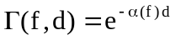 (59)
where

α(f) = coefficient of absorption as a function of frequency,
d = distance traveled through the water, and
Γ(f,d) = ratio of original intensity to intensity after absorption.

If the medium is slowly varying relative to cΔτ, the distance traveled by a single wavefront step, then this equation can be extended the inhomogeneous form:

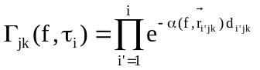 (60)
where

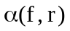 = coefficient of absorption as a function of frequency and location,
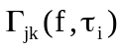 = absorption loss for a specific ray path (j,k) at time τ_{i}.
d_{i’jk} = distance along the ray path (j,k) between τ_{i’-1} and τ_{I’}.

The absorption loss modifies the strength of the beam by attenuating the intensity of each ray. This absorption loss component of propagation loss is expected to be strongly dependent on frequency.

Eigenray travel times and angles

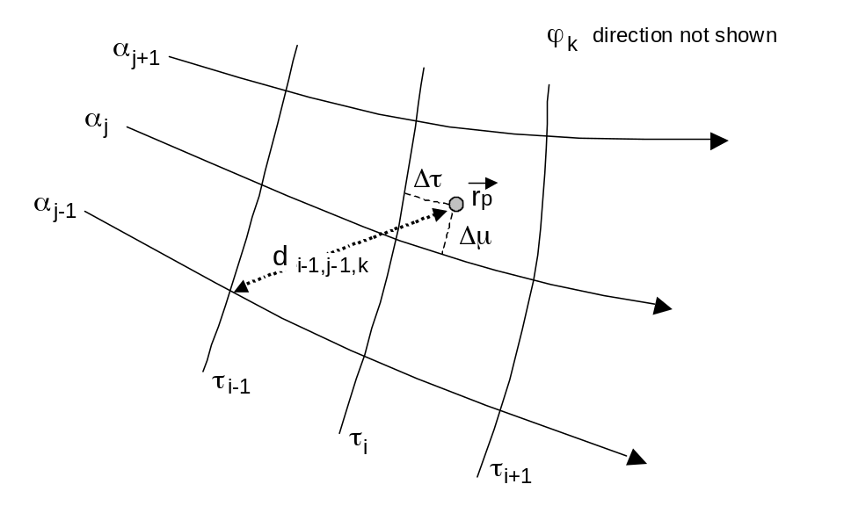
Figure 5 – Eigenray Estimation Geometry

In this model,

eigenray travel times and angles are derived from each target’s geometry relative to the closest point of approach (CPA). A point on the wavefront is considered to be the CPA if the distance to that point is less than the same measurement in the twenty-six (26) wavefront points that surround it. The coordinates for this distance calculation are illustrated Figure 5 where:

= position of the eigenray target,
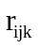 = position of the candidate points on the wavefront,
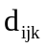 = distance from target to each point on wavefront,
Δτ = target offset along the direction of propagation,
Δμ = target offset along the depression/elevation direction along the wavefront, and
Δϕ = target offset along the azimuthally direction along the wavefront.

The square of the distance in spherical coordinate can be computed very efficiently using the using the haversine formula:

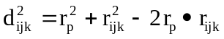 (61)
(62)
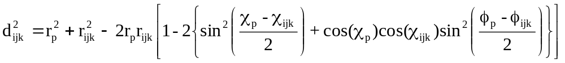 (63)
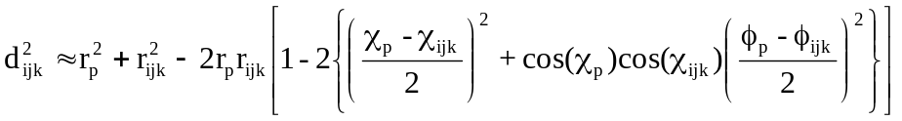. (64)
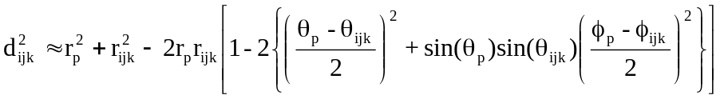. (65)
If the implementation caches values for sin(θ) at both the wavefront and target locations, eqn. 65 allows 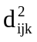to be computed without the use of any additional transcendental functions. The accuracy of this approximation improves as the distance between the target and the wavefront decreases.

To compute eigenray travel times and angles, we also need to calculate the offset of each target relative to the τ, μ, and ϕ coordinates of the wavefront. This is done by expressing as a 2nd order Taylor series, in vector form, relative to the CPA.

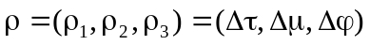 (66)
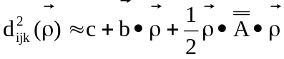 (67)
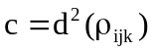 (68)
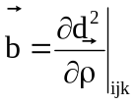 (69)
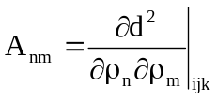 (70)
where

= offset from CPA in vector form,
c = squared distance from CPA to eigenray target,
= gradient of squared distance at CPA (3 elements), and
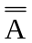 = Hessian matrix of squared distance at CPA (3x3).

One way to solve this equation would be to search for a value of for which eqn. (66) was zero. However, since is positive definite, the problem can be simplified by searching for a minimum in which is equivalent to finding a zero in the first derivative.

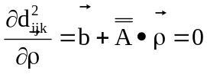 (71)
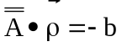 (72)
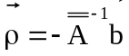 (73)
This treatment reduces the problem to the calculation of the gradient of distance, the calculation of the Hessian matrix, and a matrix inversion problem. Note that the inverse of a 3x3 matrix has a simple analytic solution that allows it to be solved efficiently and without approximation.

Some of eigenray products can are derived directly from the offset vector:

travel time = τ_{i} + δτ ,
depression/elevation angle at source = μ_{j} + δμ , and
azimuthal angle at source = ϕ_{k} + δϕ .

The direction at the target location is computed using these offsets in a quadratic Taylor series in the neighborhood of the CPA:

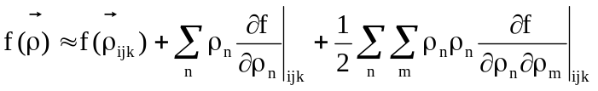. (74)
where f() represents the depression/elevation or azimuthally angle of rays in the neighborhood around the CPA.

Gaussian beam intensity

In conventional ray theory, the acoustic spreading loss is estimated by measuring the changes in ensonified area between ray paths. The intensity across the wavefront is inversely proportional to the change in surface area segment compared to the area at the source. However, conventional ray theory does not take into account the leakage of energy between regions. Gaussian ray theory emulates this leakage by giving each ray a Gaussian intensity profile across the wavefront. Cerveny originally derived the beam width using a second set of propagation equations known as the dynamic ray equations. In the GRAB model, Weinberg¹ used a faster approach which estimates the Gaussian width as a function of the vertical spreading between rays. This model seeks to combine the accuracy of the Cerveny approach with the speed of the Weinberg method.

The Cerveny approach computes the divergence of the acoustic field normal to the path of propagation. Given that all the points at each step are co-temporal, the divergence can be estimated directly from the wavefront shape without requiring the integration of the dynamic ray equations. This form of the divergence only needs to be calculated during an eigenray collision with a receiver. This calculation becomes computationally efficient when there are multiple eigenray targets for each source, but the total number of targets is small compared to the number of ray propagation iterations.

In this model, the intensity at the point of collision is an in-phase summation of Gaussian beams that surround the eigenray target. Unlike the Cerveny approach, which uses the ray paths to describe the center of the beam, this model uses the ray paths to describe the edges of the Gaussian beam (full width at half maximum). To create an acoustic field in two dimensions across the wavefront, the divergence is characterized using independent μ and ϕ terms and ignoring the cross terms. As illustrated in Figure 6, this assumption decomposes the Gaussian ray contributions to a series of nearest neighbor lines in the μ and ϕ directions.
r
p

μ

j
-
1

μ

j+1

μ

j

ϕ

k

μ

j+2

μ

j
-
2

ϕ

k+1

ϕ

k+2

ϕ

k
-
1

ϕ

k
-
2

Gaussian
beam center
Figure 6 – Gaussian Ray Nearest Neighbors

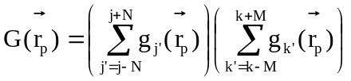 (75)
where

G = total Gaussian beam intensity at eigenray target,
(j,k) = index of cell containing the eigenray target,
g_{j’} = Gaussian beam contribution along depression/elevation direction,
g_{k’} = Gaussian beam contribution along azimuthally direction, and
2N+1 = number of significant beams in the depression/elevation direction,
2M+1 = number of significant beams in the azimuthally direction.

The intensity of each Gaussian beam contribution is a function of the width of the beam and the distance along the wavefront to the eigenray target.

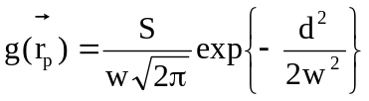 (76)
where

g = intensity of this Gaussian beam contribution,
S = this cell’s surface area contribution one meter from source,
w = half-width of the Gaussian beam (from center to one edge),
d = distance from the Gaussian beam center to the eigenray target.

Distance terms in the μ direction are calculated using the following pattern:

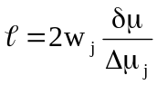 (77)
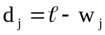 (78)
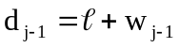 (79)
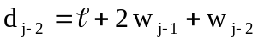 (80)
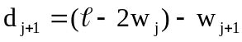 (81)
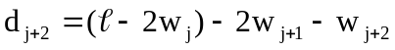 (82)
where

δμ = eigenray offset in depression/elevation angle,
Δμ_{j} = depression/elevation width of this beam at the source, and
w_{j} = width of beam “j” at the eigenray target.

The pattern in the azimuthally direction is similar and more distant cells can be supported by adding additional “2w” terms to eqns. (71) and (73).

The beamwidth is modeled using two components: a frequency independent cell width and a frequency-dependent spreading term. The evanescent spreading term is modeled as the distance which a wave of a given frequency could be expected to tunnel into an area forbidden by classic ray theory.

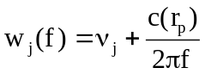 (83)
where

c = speed of sound at eigenray target,
f = frequency of the signal being modeled,
v_{j} = cell width of beam “j” at the eigenray offset, and
w_{j}(f) = frequency dependent width of beam “j” at the eigenray target.

Defining the beam width in this way is analogous to the “overlap-add method” of spectrogram estimation. The evanescent spreading term represents the spreading contribution from an infinitely narrow beam. The cell width represents the spreading effect created by the spatial sampling of wavefront. Normalizing eqn. (66) by the combined effect of both these spreading sources conserves energy across the wavefront.

Folds in the wavefront

When the wavefront reflects from the ocean’s surface or the bottom, it creates a fold in the wavefront. Wavefront folds can also be created or modified by caustics. Unlike other models, the separation of the wavefront into path types is defined by these folds and not by the number of reflections or vertices encountered along a ray path. This distinction is important when refraction causes ray paths to cross in the neighborhood of a caustic.
underlying
wavefront
direction
of travel
direction
of travel
discrete
wavefront
points
= surface reflected path
= upper vertex path
incorrect
shape
path type 1
path type 2
disallow
as CPA
caustic
Figure 7 – Folds in the wavefront

A notional example of a fold in a wavefront is illustrated in Figure 7. In this illustration, “path 1” is defined by a set of rays (solid dots) that have passed through an upper vertex and been refracted down by the sound velocity profile. Path 2 consists mostly of points that have reflected from the ocean surface (open circles), but also includes some upper vertex points that have been translated across the fold by crossing rays at a caustic.

Because the underlying wavefront is only sampled at a discreet set of locations, the shape of the wavefront cannot be determined from connections between adjacent points when those points are in the neighborhood of a fold. This model avoids the incorrect portion of the wavefront shape by excluding the point closest to each fold, and its nearest neighbors, from the search for eigenray CPA.

In this model, the phase of refracted rays changes by –π/2 when they are translated across a wavefront fold at a caustic, and not when the ray path experiences a vertex. This interpretation of the phase shift at a caustic is consistent with classic N² linear test case of Pedersen and Gordon.

N² linear test case

The author plans to provide an extensive study of test cases in a subsequent paper. But, one result is provided here to assess the accuracy of the derivations in sections 2, 3 and 4. This test case uses the shallow source version of the classic N² linear test case of Pedersen and Gordon¹³. Transmission loss is measured near the edge of a shadow zone, a traditional problem area for any model based on ray theory. The speed of sound is a strongly downward refracting and the square of the index of refraction (n²) is linear.

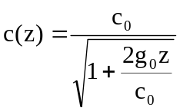 (84)
where:

c(z) = speed of sound as a function of depth,
z = depth (positive is down),
c₀ = speed of sound at the ocean surface = 1677.3319 yd/sec
g₀ = sound speed gradient at the ocean surface = 1.2286762 sec⁻¹.

Because this test case is defined in “flat earth” Cartesian coordinates, a correction must be applied to eqn. (84) before it can be used any model based on a spherical earth.

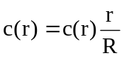 (85)
where

c(r) = speed of sound as a function of radial distance,
r = radial distance from center of earth, and
R = radius of earth curvature in this area of operations.

Figure 8 plots the coherent transmission loss for the new model, as a function of range, for a source/receiver depth of 66.7 yds, and a frequency of 2000 Hz. Target locations are analyzed between 500 and 900 yds to illustrate the behavior of the model near the edge of the shadow zone at 855 yds. Figure 8 also plots the corresponding results for the FFP wavenumber integration model, and the CASS/GRAB hybrid Gaussian beam model.

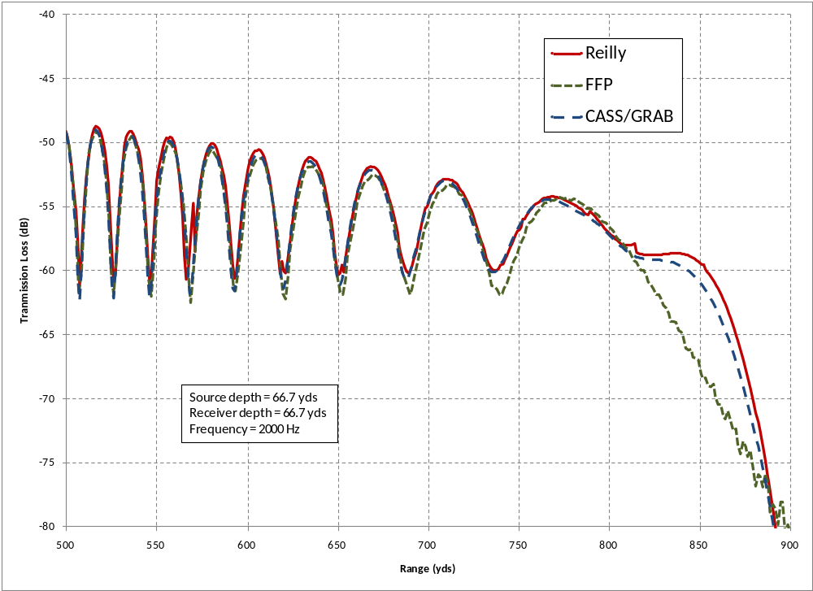
Figure 8 – Model comparisons near shadow zone edge

Note that, in all regions, the FFP result is consistent with the Pedersen/Gordon normal mode solution¹⁴, except for the presence of some minor jitter in the ranges between 850-900 yds. Away from the edge of the shadow zone, all three models produce similar results. In the region beyond 805 yds, the new model and CASS/GRAB produce values that are similar to each other, but slightly higher than the FFP result.

Summary

This paper has derived a new set of equations for propagating acoustic rays in the time domain. The form of the ray tracing algorithm and the beam width calculation differ significantly from other Gaussian beam algorithms. The computation is carried out in latitude, longitude, and altitude to speed up the extraction of data from wide-area environmental databases. By reducing the derivation to first principles, the computationally expensive trigonometric calculations have been limited to a single sin(θ) and cot(θ) factor per iteration. The interpolation of the speed of sound and its gradient has also been kept down to a single instance per iteration. Gaussian beam contributions are computed directly from the spacing between acoustic rays at each time step without the need to implement the dynamic ray equations. This algorithm is designed to provide a significant computational loading advantage in cases where multiple targets are being ensonified in a highly dynamic 3-D environment.

Acknowledgements

Efforts to test and productize this model have been funded by Alion Science and Technology, Inc. and the U.S. Office of Naval Research. The theory for reflection from a 3-D slope was developed by Dr. Michael Goodrich (Alion), who also made significant contributions to the development of test cases for this model.

This derivation uses arrows (such as “”) for vectors with magnitude and direction, carets (such as “”) for unit length vectors, and plain text for magnitude parameters (such as “r”).
This uses the same techniques as the derivation of centrifugal and coriolis forces in a spherical coordinate system.
P. A. Baxley, H. Bucker, M. B. Porter, “Comparison of Beam Tracing Algorithms,” Proceedings of the Fifth European Conference on Underwater Acoustics, ECUA 2000.
H. Weinberg, R. E. Keenan, “Gaussian ray bundles for modeling high-frequency propagation loss under shallow-water conditions.” J. Acoust. Soc. Am. 100 (3), 1421-1431, (Sept 1996).
R.M. Jones, J.P. Riley, T.M. Georges, “HARPO: A Versatile Three-Dimensional Hamiltonian Ray-Tracing Program for Acoustics Waves in an Ocean with Irregular Bottom,” NOAA, 1986.
F. B. Jensen, W. A. Kuperman, M. B. Porter, and H. Schmidt, Computational Ocean Acoustics, American Institute of Physics Press, New York, pp 151-153.
Yakowitz and Szidarovszky, An Introduction to Numerical Computation, Macmillan Publishing, 1986, pp 306-311.
W. Press, S. Teukolsky, W. Vetterling, B. Flannery, Numerical Recipes in C, Cambridge University Press, 1992, pp 747-752.
“WGS 84 Implementation Manual,” Version 2.4, European Organization for the Safety of Air Navigation, and the Institute of Geodesy and Navigation, February 12, 1998
R. W. Sinnott, “Virtues of the Haversine,” Sky and Telescope, 68, pp. 159-159, 1984.
M. B. Porter, H. P. Bucker, “Gaussian beam tracing for computing ocean acoustic fields,” J. Acoust. Soc. Am. 82 (4), October 1987, pp. 1349-1359.
V. Cerveny, M. M. Popov, and I. Psencik, “Computation of wave fields in inhomogeneous media – Gaussian beam approach,” Geophys. J. R. Astron. Soc., 70, pp. 109-128, 1982.
F. B. Jensen, op. cit., pp. 121-131,
A. V. Oppenhiem, R. W. Schafer, Digital Signal Processing, Prentice-Hall Inc., New Jersey, 1975, pp. 113-114.
M. A. Pedersen, D. F. Gordon, "Normal-Mode and Ray Theory Applied to Underwater Acoustic conditions of Extreme Downward Refraction", J. Acoust. Soc. Am. 51 (1B), 323-368 (June 1972).
F. R. DiNapoli, R. L. Deavenport, "Theoretical and numerical Green's function field solution in a plane multilayered medium", J. Acoust. Soc. Am. 67(1), Jan 1980.
L. M. Brekhovskikh, Waves in Layered Media, 2nd Edition, Academic Press Inc., 1980, Section 54.
Naval Meteorology and Oceanography Command, “Software Requirements Specification/Software Design Description and Software Test Description for the Oceanographic and Atmospheric Master Library Navy Standard Comprehensive Acoustic System Simulation Model Version 4.2A,” OAML-SRS-SDD-STD-83D, October 2008,

